**CUBE and ROLLUP Operators in SQL**

The **CUBE** and **ROLLUP** operators are SQL extensions used for **aggregating** data across multiple dimensions in a structured and efficient way. They help in generating summary reports and are particularly useful in **OLAP (Online Analytical Processing)** and **data warehousing**.

**1. CUBE Operator**

**Concept:**

* The **CUBE** operator **computes all possible combinations** of aggregations across the specified dimensions.
* It **generates a multidimensional** summary of the data by considering every possible grouping of the given attributes.
* It is particularly useful when we need **subtotals for all attribute combinations** and the **grand total**.

**Example Use Case:**

Consider a sales dataset with **ProductCategory, Region, and Year** as attributes. Using CUBE, we generate all possible groupings of these attributes.

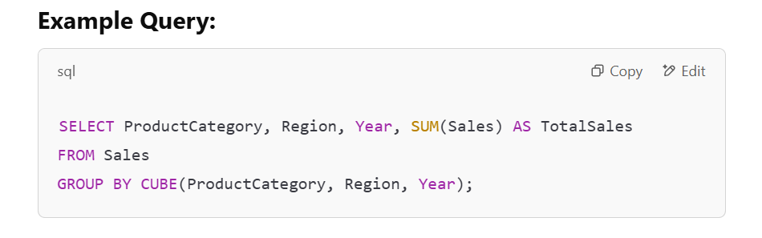

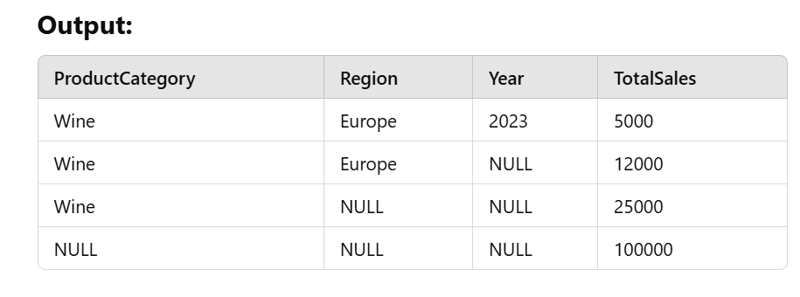

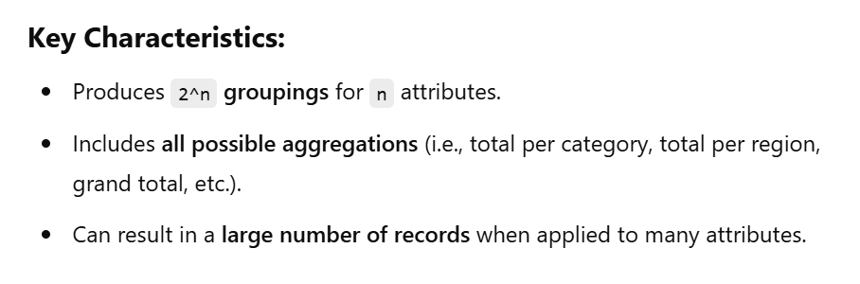

**2. ROLLUP Operator**

**Concept:**

* The **ROLLUP** operator is a **hierarchical version of CUBE**, generating **aggregations in a specific order**.
* Instead of computing all combinations like CUBE, it **progressively aggregates** data from the most detailed level up to the grand total.
* It is often used for **hierarchical reports**, such as **Year → Quarter → Month** summaries.

**Example Use Case:**

Suppose we want to compute **sales totals by Year, then Region, and then a Grand Total**.

**Example Query:**

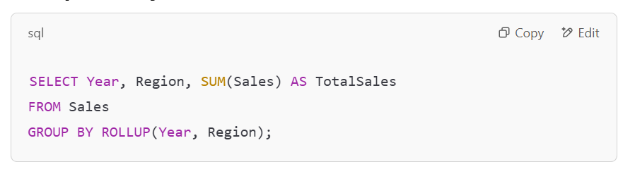

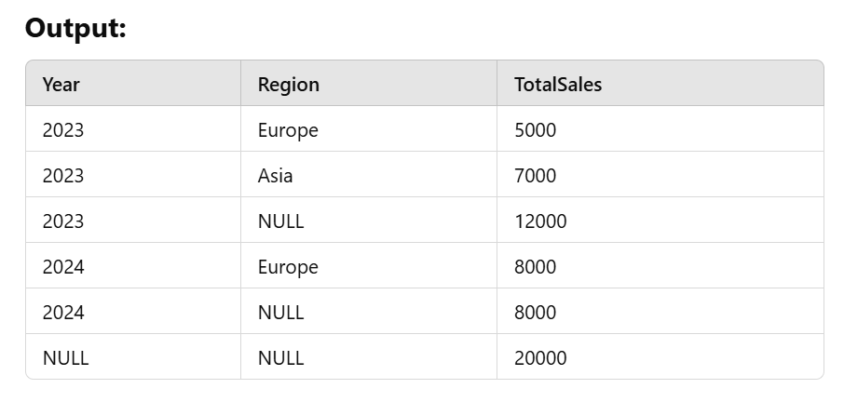

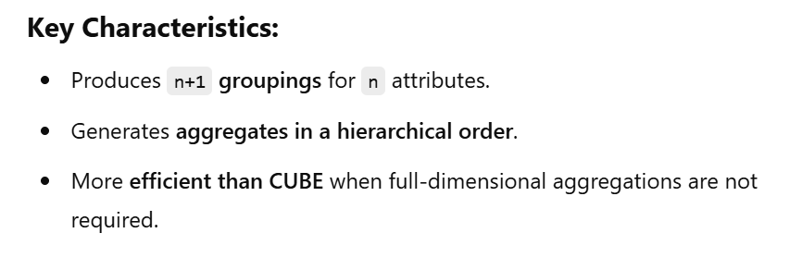

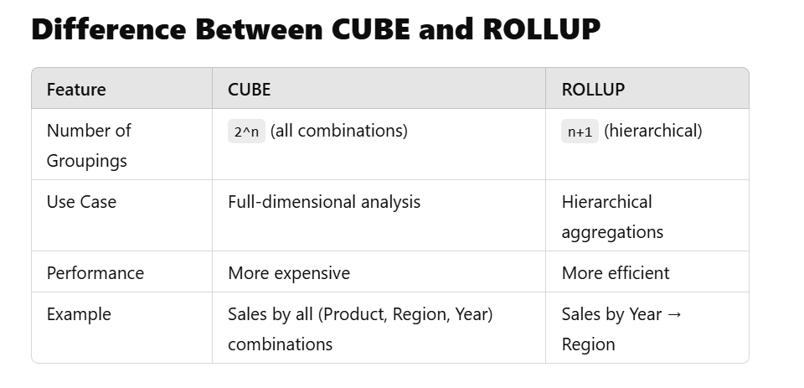

**Choosing Between CUBE and ROLLUP**

* Use **CUBE** when **all** possible aggregations are required.
* Use **ROLLUP** when **hierarchical aggregations** (e.g., Year → Region) are needed.